Input paper: [1] ENG19-3.1.1.7

Input paper for the following Committee(s): check as appropriate Purpose of paper:

**□** ARM **☑** ENG **□** PAP **☑** Input

**□** DTEC **□** VTS **□** Information

Agenda item [2] X

Technical Domain / Task Number 2 Task 2.1.6

Author(s) / Submitter(s) CHINA MSA

AtoN Light Detection System Based on Image Processing Technology

# Summary

This proposal introduces the AtoN light detecting system which adopts the image processing technology which is being developed by China MSA.The system is designed with a multi-dimensional rotating imaging module that includes a camera, a filtering module, and a 3D PTZ. It uses a multi-modal ranging module with laser ranging and GPS positioning modules, combined with real-time automatic identification, tracking, and detection algorithms for AtoN lights, to achieve measurement of the flashing rhythm, period, color, and luminous intensity of various AtoN lights in the marine on-site environment.

## Purpose of the document

This proposal provides an on-site detection method based on artificial intelligence. It can be added to the *Guideline for Measurement of Marine Light Performance* that is being developed, aiming at promoting the work of this task.

## Related documents

ENG17-3.1.1.13.2 ANNEX B Draft IALA Guideline - Measurement of Marine Lights Performance 1

# Background

The flashing rhythm, period, color and light intensity of AtoN light are important technical indicators. Real-time mastering the indicators during on-site inspection, effectiveness evaluation, and acceptance of navigation lights is of great significance to verify that AtoN lights can provide good navigation assistance .China MSA has been organizing the research on intelligent detection methods of AtoN light since 2017, the portable AtoN light character detector based on spectral analysis technology has been developed in the early stage. Although this detector can realize the testing of flashing period and rhythm in laboratory and field , the color needs to be detected in dark room. Light intensity still needs the Illumination photometer to measure because it cannot be detected.In addition, when we carry out on-site detection, the floating AtoN lights would fluctuate irregularly, and the detecting ship would swing and drift inevitably. To ensure the detector’s telescope can capture the signal continuously, the detectors have to track the target manually, which requires for certain techniques and experiences.

Unlike the preliminary achievements that used spectral analysis technology, China MSA is developing an AtoN light detection equipment based on image processing technology and deep learning technology. It integrates on-site detection of the rhythm, period, color, and light intensity of AtoN lights, using automatic tracking method to detect indicators such as the rhythm, cycle, color, and effective distance of AtoN lights during routine inspection and buoy efficiency acceptance. This plays an important role in carrying out refined management and improving navigational assitance effectiveness of AtoN lights

# Discussion

## Technology roadmap

The technical roadmap for the research of AtoN detection system based on image processing technology is shown in Figure 1.

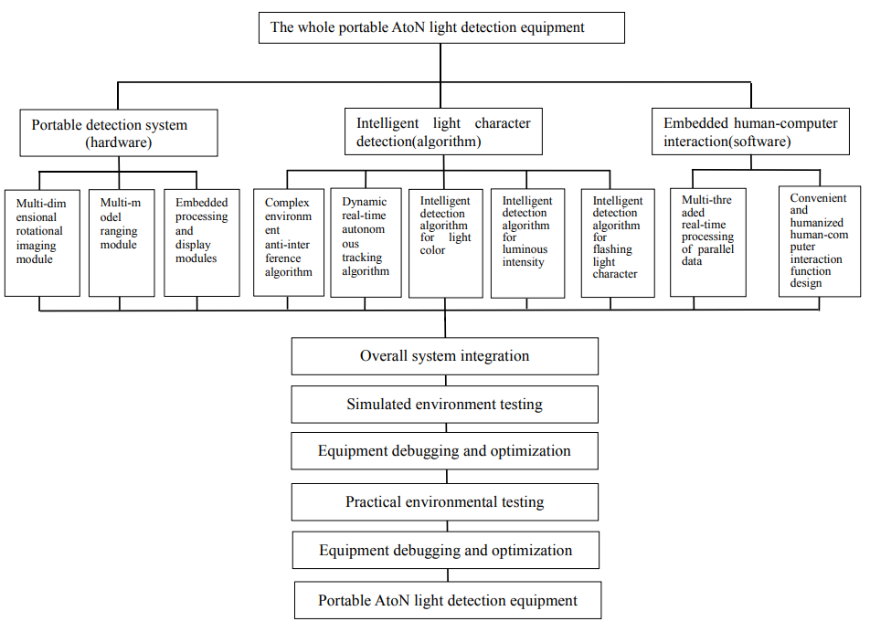

1. The technical roadmap for the research of AtoN detection system based on image processing technology

The whole detection equipment mainly includes three modules: hardware module, intelligent detection algorithm, and human-computer interaction software. Portable detection hardware system is composed of multi-dimensional rotation imaging sub-module, multi-modal ranging sub-module, and embedded processing display sub-module.The intelligent light character detection algorithm integrates complex environment anti-interference algorithms and dynamic real-time autonomous tracking algorithms for data pre-processing. It conducts intelligent algorithm detection of color, light intensity, rhythm, and cycle, and ultimately performs concurrent multi-line real-time processing of data in the human-computer interaction software module, providing users with a convenient and user-friendly interactive operation interface.

## System analysis

According to the analysis of the demand of AtoN light detection,the system design block diagram is as shown in Figure 2. The whole system consists of camera, lens, polarizer, laser rangefinder, PTZ, embedded processor, touch screen monitor, and power supply module.

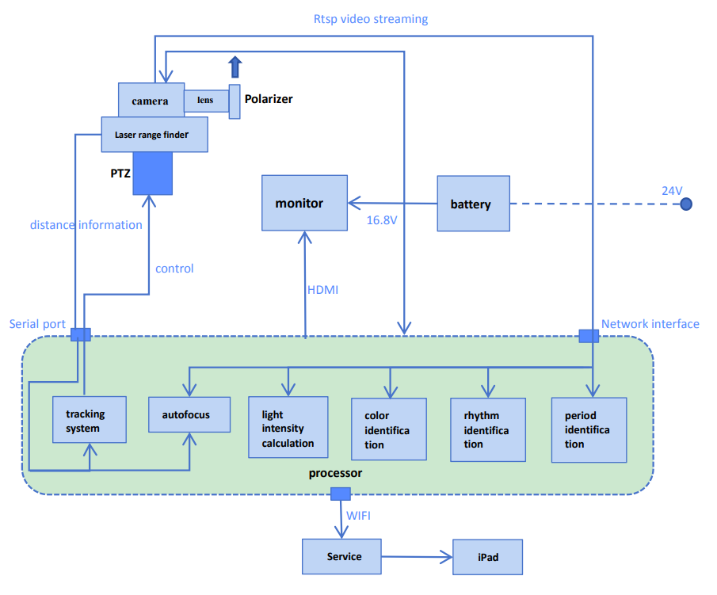

1. The overall structure of AtoN detection system based on image processing technology

### Hardware system

The hardware system adopts an optical imaging system which is based on a high resolution camera, a multi-dimensional rotation module, and a high-performance optical filter, using RTSP (Real Time Streaming Protocol) to acquire images, using serial port to angle control so as to track the target objects.

* Multidimensional rotational imaging module

A multi-dimensional rotational imaging module was built using a camera,a filter module, and a 3D PTZ.The rotation operation of the imaging module is automatically controlled by tracking algorithms and IO commands to achieve real-time tracking and capturing of the motion of the beacon lights, and to stabilize the acquisition of AtoN light images. At the same time, it intelligently obtains clear images based on the best clarity evaluation algorithm.The 3D PTZ can automatically adjust the translation and pitch angles according to the offset position of the AtoN lights to ensure that the AtoN lights remain within the field of view.

* Multi-model ranging module

It adopts a dual-mode complementary measurement module based on laser rangefinder and GPS. The acquired data can be calculated to obtain accurate results so as to achieve precise measurement of relative position information and lay a solid foundation for calculating the intensity of navigation lights.

### Algorithm system

* Complex environment anti-interference algorithm

Image processing technology is used to simulate various complex weather and special situations such as darkness that may occur at sea, and to create the required data set for model training by adjusting multiple indicators such as contrast, brightness, chromaticity, and clarity of AtoN lights’ images.

* AtoN light real-time detection algorithm

The YOLOv5 network is built to achieve rapid detection of AtoN light videos, images, and real-time dynamic images, and to accurately classify different types of AtoN lights by extracting appearance features such as shape, color, and size of AtoN lights.

* AtoN light real-time tracking algorithm

A twin neural network is selected, learning the motion trajectory of the AtoN lights between the front and rear frames, the characteristics of the AtoN lights themselves, and the degree of correlation between the front and rear frames so as to achieve real-time and rapid tracking of the AtoN lights.

* AtoN light colour detection algorithm

Colour information of ROI regions is extracted from the collected video signals,and take the average of the statistical values of the color information in the ROI area, and then map the extracted color information to the AtoN light signal color chromaticity area recommended by IALA.

* AtoN light period and rhythm detection algorithm

Time of the color change of the AtoN lights is recorded. We record the time of each color change and the number of color changes at the same time so as to obtain the flashing cycle and rhythm of the AtoN lights

* AtoN light luminous intensity detection algorithm

A large amount of grayscale value and illuminance data for different colors and models of AtoN lights are collected, then fit and the data to establish an illuminance data model. Using the model as a mapping relationship between grayscale value and illuminance, and then calculate the luminous intensity information according to the measured distance information.

### Human-computer interaction software system

* Real-time processing of concurrent data through multiple threads

In order to improve the efficiency of software system data processing, this system uses thread parallel processing for image algorithm, rotation control, and business logic respectively.Increasing the priority of tracking algorithm threads to form a closed loop for image acquisition, calculation, and control, so as to realize accurate tracking and real-time detection of AtoN lights.

* Convenience and user-friendly design of human-computer interaction functions

The software interaction interface displays content includes camera control, AtoN light detection results, and camera video footage,etc,which can achieve real-time display of the AtoN light detection effect. At the same time, operators can control the device and operate the program functions by clicking the interface buttons. The human-computer interface is shown in Figure 3.

.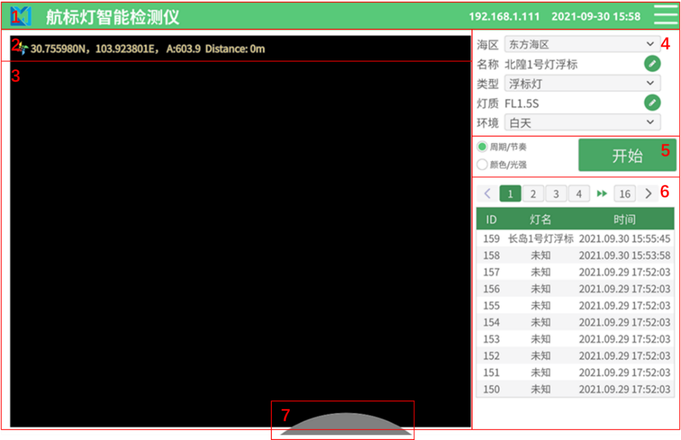

1. The human-computer interaction interface

## Realization and testing

The material object of the detection system is shown in Figure 4. At present, China MSA is testing the detection system and will optimize it based on the testing results in the future.

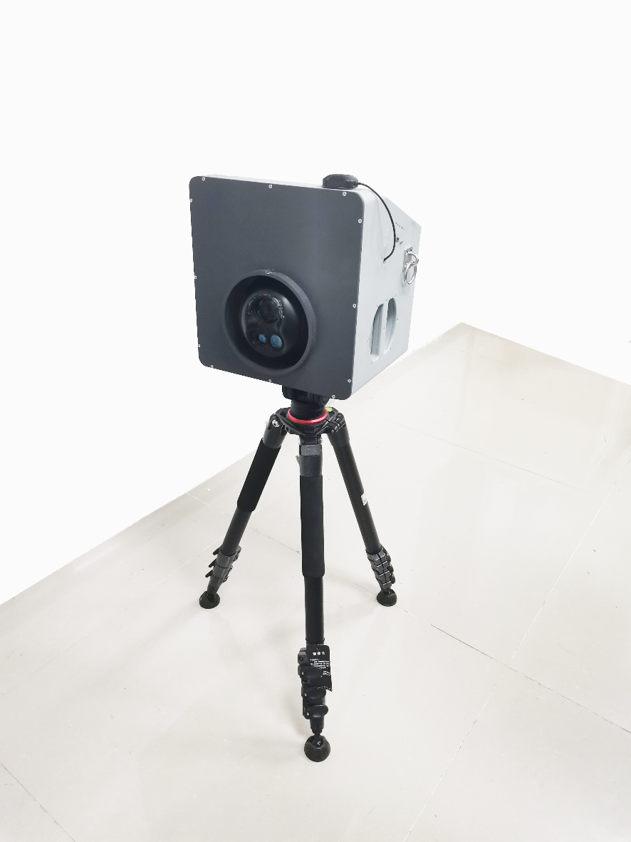

1. AtoN detection system based on image processing technology

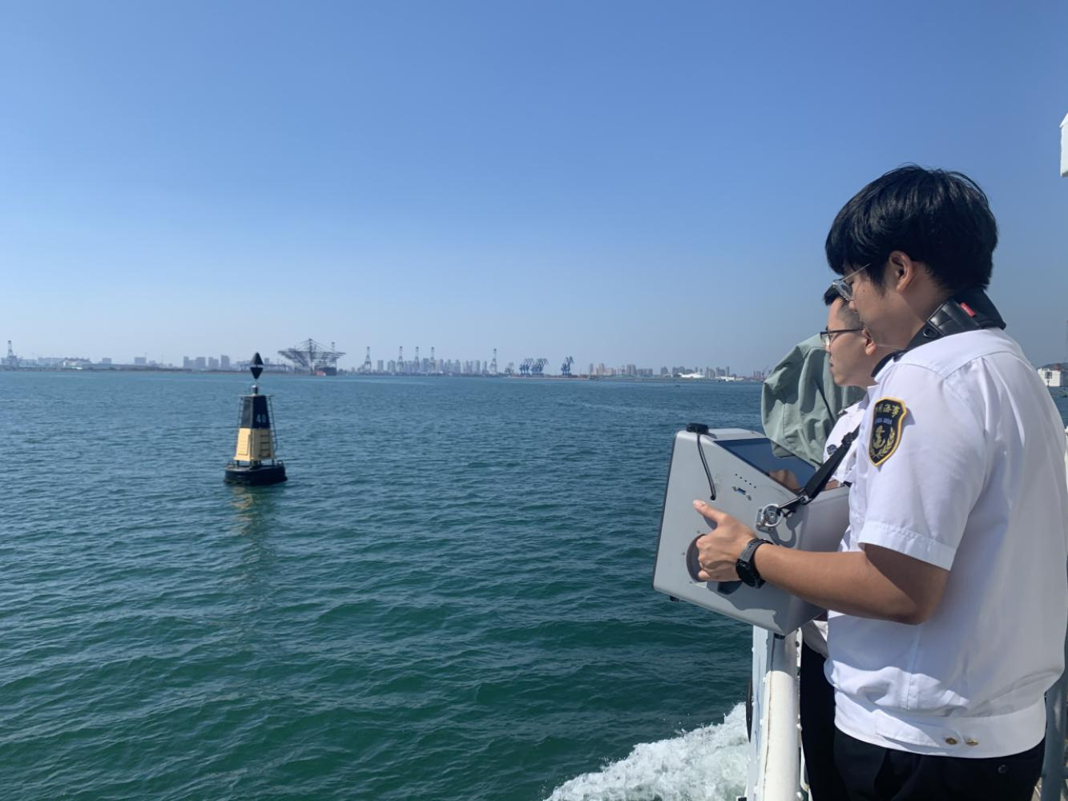

1. On-site testing

## Conclusion

Based on the above introduction of this detection system, the following content is recommended to add to the on-site measurement chapter of the draft *Guideline for Measurement of Marine Light Performance*.

Unlike traditional spectroscopic methods such as photometers or spectrometers, the luminosity and chromaticity detection of AtoN lights based on image processing has the following characteristics:

* Remote acquisition of AtoN light signals using photoelectronic imaging technology

On-site measurement of AtoN lights generally requires remote telemetry. If traditional detection equipment such as photometers and spectrometers are used, it is necessary to align the device probe with the AtoN light source accurately. However, in the case of remote telemetry, it is difficult to calibrate the attitude between the detector and the light source to maintain precise alignment between the two. Due to its large field of view, photoelectric images can easily capture the measured object. Therefore, this method adopts technology based on image to achieve the acquisition of AtoN light signals.

* Automatic recognition and long-term tracking of AtoN lights based on deep learning algorithms

When using photoelectric imaging technology to obtain AtoN light images, in order to make the images clear, the imaging system needs to be zoomed in, but its field of view will also be narrow. In addition, the actual situation of the floating buoy swaying and the tester waggling with the ship will make the AtoN light run out of the imaging system’s field of view. Therefore, based on imaging, this method designs a single object detection, recognition, and long-term automatic tracking algorithm based on deep learning to achieve real-time automatic recognition and tracking of AtoN lights, in order to achieve stable acquisition of AtoN light images.

* Integrated detection of performance parameters of AtoN lights by image processing technology

Unlike traditional detection methods, in order to achieve simultaneous on-site detection of the character, color, and luminous intensity of AtoN lights by the same equipment, this method uses image processing technology to crop and balance the location information in the tracked AtoN light image, analyze the grayscale value distribution curve of the light source , and identify the flashing rhythm, cycle, and color information of AtoN lights. By collecting and fitting a large amount of grayscale and light intensity data for different colors and types of AtoN lights in the early stage, a grayscale illuminance data model is established. Combined with distance information, the luminous intensity of AtoN light can be calculated.

# References

1. IALA Recommendation E-200-3 - Marine Signal Lights, Part3 - Measurement [J].
2. REDMON J, DIVVALA S, GIRSHICK R, et al. You Only Look Once: Unified, Real-Time Object Detection; proceedings of the 2016 IEEE Conference on Computer Vision and Pattern Recognition (CVPR), F 27-30 June 2016, 2016 [C].
3. ALEXEY B, CHIEN-YAO W, HONG-YUAN M L. YOLOv4: Optimal Speed and Accuracy of Object Detection [J]. arXiv preprint, 2020, arXiv:2004.10934v1
4. REDMON J, FARHADI A. YOLO9000: better, faster, stronger; proceedings of the 2017 IEEE Conference on Computer Vision and Pattern Recognition (CVPR), 21-26 July 2017, Los Alamitos, CA, USA, F, 2017 [C]. IEEE Computer Society.
5. REDMON J, FARHADI A. YOLOv3: An Incremental Improvement [M]. Internaltional Conference on Computer Vision and Pattern Recogintion(CVPR). Salt Lake City, Utah. 2018.
6. Li M , H Zhu, H Chen, et al. Research on Object Detection Algorithm Based on Deep Learning[J]. Journal of Physics: Conference Series, 2021, 1995(1):012046 (5pp).
7. Fan H, Lin L, Yang F, et al. Lasot: A high-quality benchmark for large-scale single object tracking[C]//Proceedings of the IEEE/CVF conference on computer vision and pattern recognition. 2019: 5374-5383.
8. BERTINETTO L, VALMADRE J, HENRIQUES J F, et al. Fully-convolutional siamese networks for object tracking; proceedings of the 14th European Conference on Computer
9. Dalal N, Triggs B. Histograms of oriented gradients for human detection[C]//2005 IEEE computer society conference on computer vision and pattern recognition (CVPR'05). Ieee, 2005, 1: 886-893.
10. Felzenszwalb P, McAllester D, Ramanan D. A discriminatively trained, multiscale, deformable part model[C]//2008 IEEE conference on computer vision and pattern recognition. Ieee, 2008: 1-8.
11. Felzenszwalb P F, Girshick R B, McAllester D, et al. Object detection with discriminatively trained part-based models[J]. IEEE transactions on pattern analysis and machine intelligence, 2009, 32(9): 1627-1645.
12. Bo W , Nevatia R . Detection and Tracking of Multiple, Partially Occluded Humans by Bayesian Combination of Edgelet based Part Detectors[J]. International Journal of Computer Vision, 2007, 75(2):247-266.
13. Arthur D, Vassilvitskii S. k-means++: The advantages of careful seeding[R]. Stanford, 2006.
14. Rezatofighi H, Tsoi N, Gwak J Y, et al. Generalized intersection over union: A metric and a loss for bounding box regression[C]//Proceedings of the IEEE/CVF conference on computer vision and pattern recognition. 2019: 658-666.

**5. Action required of the committee**

The committee is requested to note the work conducted by China on the detection of AtoN lights, include the section 3.4 of this proposal in Chapter 11 of the draft *Guideline for Measurement of Marine Light Performance*, and include the remaining parts in the appendix.

1. Input document number, to be assigned by the Committee Secretary

   Leave open if uncertain
2.